WHITE WOMAN LANE SCHOOL                                                    Issue 28 Week Ending Friday 22nd April 2016

White Woman Lane, Sprowston, Norwich. NR6 7JA

Telephone:     01603 419203       Fax:  01603 424651

Email:             office@whitewomanlane.norfolk.sch.uk

Website:         [www.whitewomanlane.norfolk.sch.uk](https://webmail.nsix.org.uk/owa/redir.aspx?C=7539346b7e614fde862d769e09edfc97&URL=http%3a%2f%2fwww.whitewomanlane.norfolk.sch.uk%2f)

Twitter: @whitewomanlane

**Best News…**

**Dear Parents/ Carers,**

The Week Ahead

**Mon. 25th - Yr 3/4 Tag Rugby 12.35 (before second sitting)**

**Dance Club School hall 3.20 – 4.20pm**

**Tues. 26th - Guitars lessons am**

Yr 5/6 Korfball Lunchtime (after first sitting)

**Drums pm Mobile**

**Yr 5/6 Korfball 3.20 – 4.15pm**

**Wed. 27th - Year 5 Tudor Day (Rescheduled for today)**

**Guitars lessons am**

**Yr 4,5 and6 Cross Country Lunchtime (12.35-before second sitting)**

**Keyboard lessons**

Woodwind lessons

**Skillforce**

**Thur. 28th**  **- Korfball Year 3/4 Lunchtime (after first sitting)**

**Samba Club School Hall 3.15 – 4.30pm**

**Drums pm Mobile**

**Tennis Yr 4 3.20 – 4.20pm**

**Fri. 29th -**

Dates for Your Diary:

Wednesday 4th May – Star Wars themed dress up day raising money for Cancer Research UK

Monday 9th May – Deadline for Scholastic orders

Wednesday 29th June (PM) Children’s University Graduation (for those with up to 100 hours)

NB – Possible change to date previously published: Children’s University Graduation (for those with 100+ hours). We will update you as soon as we have confirmation.

W/C 11th July - End of year Assertive Mentoring meetings

**THE ATTENDANCE CUP**

**j0299175**

Was awarded to

6B and 4S

With attendance of 100**%**

For the week 11th – 15th April 2016

**HOUSEPOINT TOTALS**

**j0299175**

**Buckingham** (Green) 266 **Total** - 51

**Balmoral** (Blue) 336 **Total** - 64

**Sandringham** (Yellow) 237 **Total** - 52

**Windsor**  (Red) 314 **Total** - 73

Congratulations to **Balmora**l this week!

**GOLDEN BOOK AWARD**

Congratulations to the following pupils for providing us with ‘WOW’ moments and for being entered into our Golden Book;

**Lennon Murphy and Olivia Stevenson**

**Parking**



Unfortunately we have received complaints from our neighbours in Impala Close (side entrance to school). It is alleged that cars are being parked across driveways and on the corner of the close as well as cars being reversed out of the close.

We and our neighbours are concerned for the safety of any pedestrians using the pathways and we therefore ask that extra care is taken when using Impala Close to drop off and collect children by car.

We also value the good relationship with our neighbours so we would appreciate it if parents could avoid obstructing entrances to people’s drives.

Thank you for your cooperation.

**Cake and Bake Sale**



The Year 6 Librarians held a Cake and Bake Sale on Thursday 14th April, raising funds to fulfil the children’s book requests from the Library Bus suggestion box.

Thank you to everyone who donated a wide range of scrummy cakes and bakes for the sale and to all those who came along a purchased a yummy treat…or two! Your fantastic support helped to raise £55.10. Thank you!

If you missed the recent cake sale however, or you fancy more of the same, then you will be delighted to hear that we have another sale planned!

Year 5 will be selling cakes and bakes on **Friday 29th April** at break time in the DT area. They wish to raise money and split it between three chosen charities:

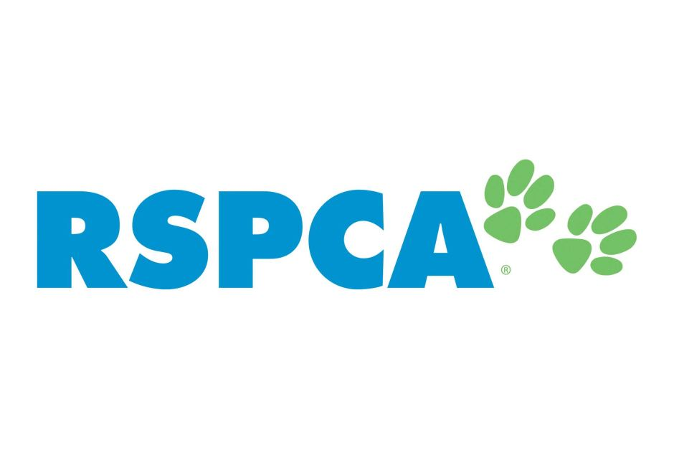



http://www.wateraid.org/uk/~/media/Images/Global/Icons-and-logos-including-social-media/wateraid-logo.jpg

Any donations of cakes and bakes for the sale would be gratelly received and can be brought in on the morning of the sale. Please remember to label your containers so that we can return them to you with your child!

Thank you

**Maths App of the Week!**



**Chicken Coop Fractions** (Lumpty Learning)

A game estimating the closest decimal equivalent to a fraction.

**TALK HOMEWORK & ‘WOW’ WORDS**

Each week we send a Talk Homework activity and ‘Wow’ Words home and we would be very grateful for your support.

We are trying to help all our children develop excellent speaking and listening skills, which in turn will help them with their writing. “If a child can’t say a sentence then they can’t write it either!”

Please spend at least 10 minutes talking with your child about the questions below;

**The Queen’s 90th Birthday**

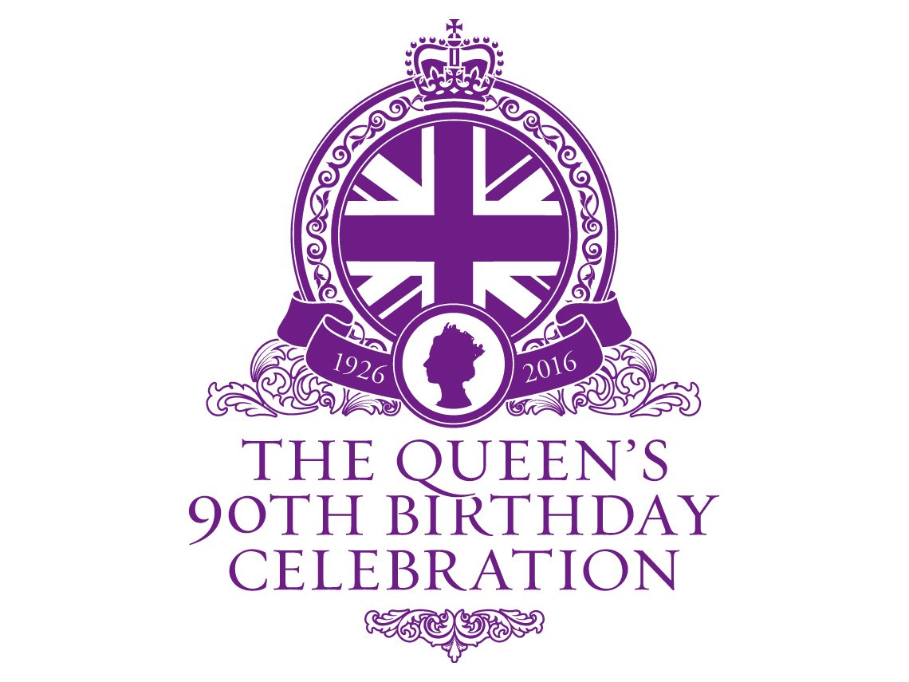

The Queen's actual birthday was on 21st April, and that's when the celebrations started, with a walkabout in Windsor. In the evening the Queen lit the first of 1,000 beacons stretching across the country and around the world!

On 12th - 15th May at Windsor Castle there will be a spectacular 4-day birthday party event, the finale of which will be broadcast live on Sunday night. The extravaganza will celebrate Queens Elizabeth's life, her love of horses, her dedication to the Commonwealth and her support of our Armed Forces.

On 11th June it's time for the official birthday celebration and Trooping the Colour, followed by a balcony appearance at Buckingham Palace from The Royal Family and an exciting fly-by.

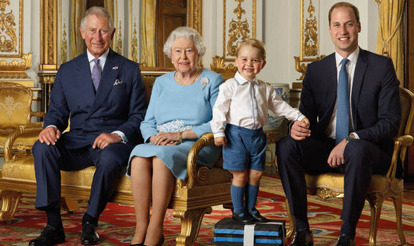

* Do you think it is important to celebrate the Queen’s 90th Birthday? What are your reasons for or against?
* What present would you buy the Queen and why?
* If you met the Queen what would you want to find out about her life?

*In Big Talk, we use ‘WOW’ Words to improve our vocabulary*





*and ‘big up’ our sentences to make them more interesting*

*Our ‘WOW’ Word this week is;*

***Celebration***

*(Festival, Party, Gala, Jubilee, Festivity)*

***Please encourage your child to use this word,***

***in the right context, as much as possible.***

**• The ‘Talk Homework’ and ‘WOW’ words will be set every Friday in the newsletter; children will then share their ‘Talk’ with their class on a Tuesday morning.**

**• We will encourage the children to use the WOW word throughout the week.**

**Thank you for your support in helping your child.**

**dd01184_ STARS OF THE WEEK dd01184_**

**Liam Gascoyne 3S**

For his extremely good behaviour this week. He has always been listening and never needs to be told to do his work twice.

**Amelia Laws 3S**

For trying exceptionally hard in al lessons this week and impressing me with her attitude.

**Sienna Brown 3C**

For her insightful and poignant talk to the class about D-Day. Well done, Sienna.

**Joshua Thomson 3C**

For ‘wowing’ his teachers with the impressive riddle he wrote in literacy. Fantastic work, Josh!

**Ruby Farrow 4S**

For displaying good reading expression and thoughtful insight and ideas in guided reading.

**Jayden Goodall 4S**

For making an effort to concentrate and engage more in maths, leading to much improved knowledge of time.

**Emil Oulare 4P**

For a truly superb reading diary over the Easter holidays.

**Jessica Butler 4P**

For a fantastic 1st week at WWL. Jessica has settled well and thrown herself into all activities. Superb!

**Josh Abbs 5B**

For thoughtful and consistent contributions to discussion.

**Jude Frostick 5B**

For being Jude! Also for good contributions in Guided Reading.

**Spencer Boyd 6B**

Great reasoning and contributions in Guided Reading.

**Lewis Sutton 6B**

Great effort in Geography using an atlas.

**Owen Pamplin 6B**

For working so hard in Springboard.

**Kaia Mager-Brink 6B**

For working so hard in Springboard.

**Amber Cresswell 6J**

For working extremely hard over the Easter break to learn her spellings.

**Jessica Davies 6J**

For impressing Miss Brunning with lots of fantastic contributions during grammar lessons.

**William Davison 6Q**

For inventing disgusting ingredients for his Hogwarts potion!